5.3 EXERCISE 2 - electrochemical cells

1. Draw the conventional representation of the electrochemical cells to show how you would use the following reactions to make electricity (they are all spontaneous). In each case indicate the polarity of the electrodes.

- Fe(s) + Cu²⁺(aq) → Fe²⁺(aq) + Cu(s)
- 2Fe³⁺(aq) + 2I⁻(aq) → 2Fe²⁺(aq) + I₂(aq)
c) Zn(s) + 2H⁺(aq) → Zn²⁺(aq) + H₂(g)
d) 2H₂(g) + O₂(g) → 2H₂O(l)

2. Deduce the chemical reaction taking place in the following cells, given the following data:

Half-reaction | E/V
Zn²⁺(aq) + 2e → Zn(s) | -0.76
Fe²⁺(aq) + 2e → Fe(s) | -0.44
Fe³⁺(aq) + e → Fe²⁺(aq) | +0.77
Ag⁺(aq) + e → Ag(s) | +0.80
Cl₂(g) + 2e → 2Cl⁻(aq) | +1.36

a)
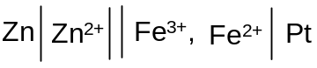

b)
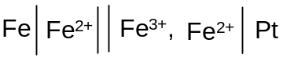
c)
